1: Bar Plot of VS

count1<-table(mtcars$vs)

barplot(count1,main="Bar Plot of VS",xlab="V and S",ylab="COunts",col="red")

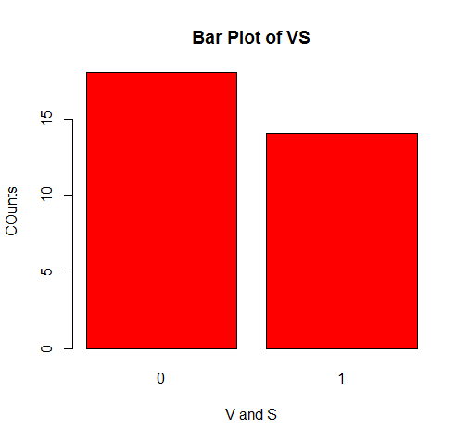

BAR PLOT OF GEARS

|  |
| --- |
| #BAR PLOT FOR GEARS  > count3<-table(mtcars$gear)  > barplot(count3,main=" Bar Plot of Gear",xlab="Gear",ylab="Counts of Gear",col="red") |
|  |
| |  | | --- | | > | |

BAR PLOTS OF AM

|  |
| --- |
| # BAR PLOT OF AM  > count4<-table(mtcars$am)  > barplot(count4,main=" Bar Plot of A&M",xlab="A&M",ylab="Counts ",col="red") |
|  |
| |  | | --- | | > | |

|  |
| --- |
| # BAR PLOT OF CARB  >  > count4<-table(mtcars$carb)  > count5<-table(mtcars$carb)  > barplot(count5,main=" Bar Plot of carb",xlab="carb",ylab="Counts ",col="red") |
|  |
| |  | | --- | | > | |

5(3)

Write a program to create a plot density by class variable.

> d<-density(mtcars$mpg)

plot(d,main="Density of mpg")

> polygon(d,col="blue")

